PN JUNCTION SILVACO TCAD SIMULATION REPORT
Q1a)
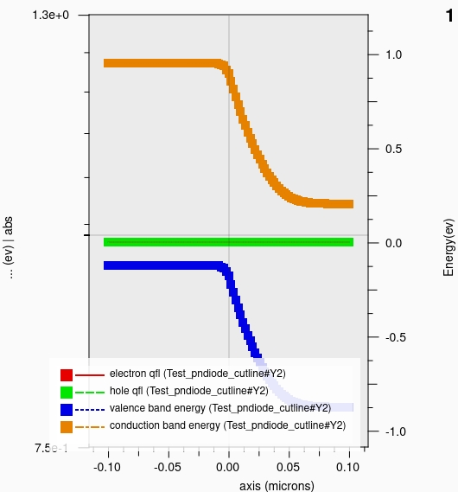
b)
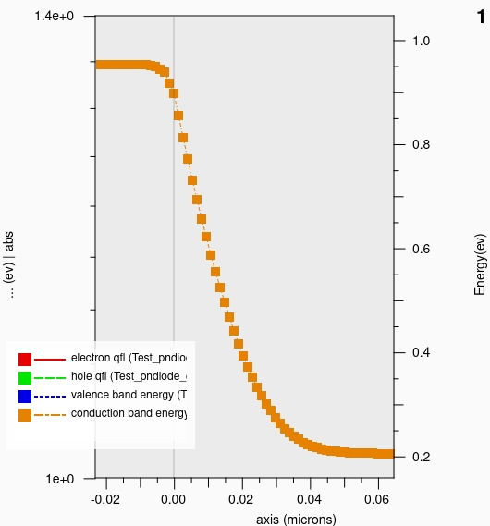
c)
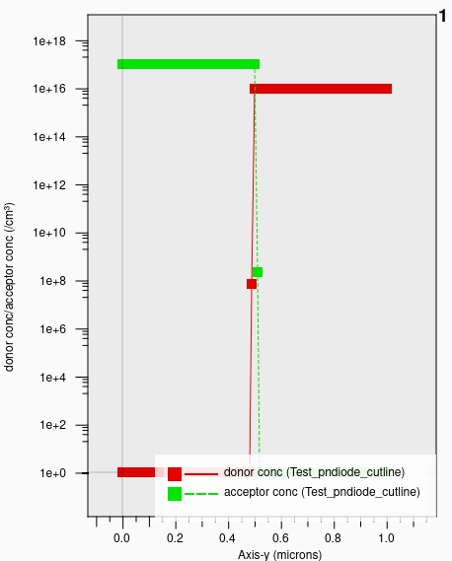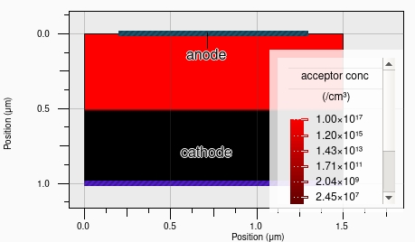
d) Max ptype doping is ${10}^{17}/cm3$
e)
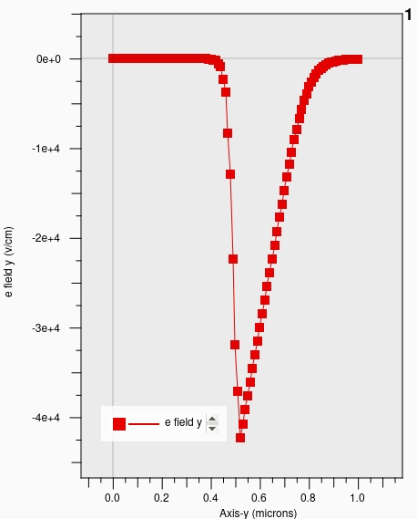
From the plot Max Electric field is approx. $4.23 x {10}^{4}v/cm$
Analytically;
$$E=\frac{2V_{bi}}{W}=\frac{2\left(\frac{kT}{q}\ln\left(\frac{NAND}{{N_{i}}^{2}}\right)\right)}{\sqrt{\frac{2ϵV_{bi}}{q}(\frac{1}{NA}+\frac{1}{ND}})}=4.7 x {10}^{4}v/cm$$
The simulation and analytic solutions agree at some point.
Q2 a)
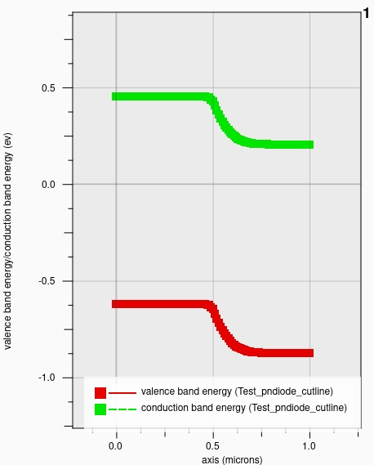
b)The effective barrier height is approx. 0.25eV
Q3 a)
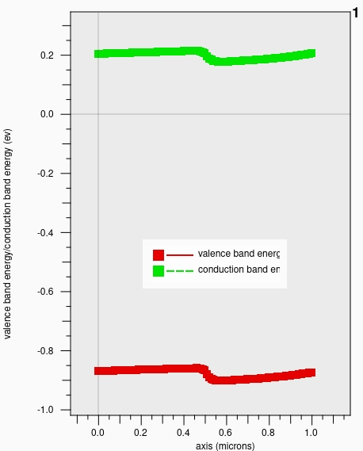
b)The effective barrier height is approx. 0.04Ev
Q4 a)
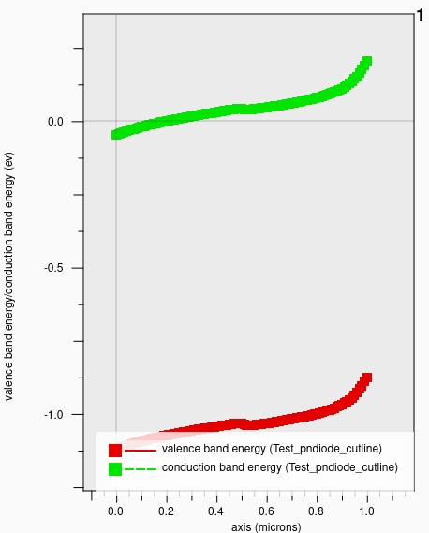
Q4 b)
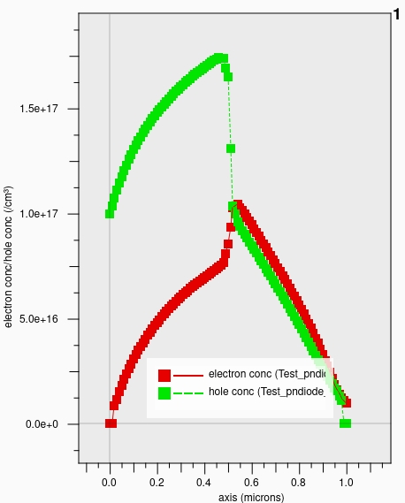
The junction is in high-level injection at 1 V.
Both electron and hole concentrations become comparable (~10¹⁷ cm⁻³) near the junction.
The depletion region is very narrow.
c)
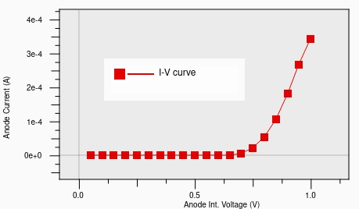
d) At 1V forward bias, the analytical depletion‐width expression predicts that the depletion region would vanish (since VA​>Vbi​), so the simple depletion approximation is no longer valid. The TCAD result shows a very small band bending, consistent with the fact that the junction is in strong forward/high-level injection.
Q5 a)
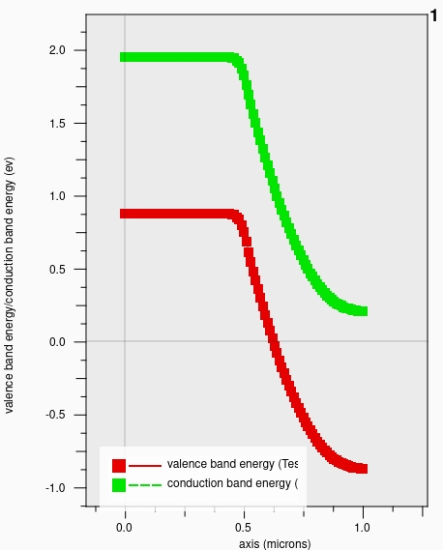
b)Effective barrier height is 1.7eV
c)
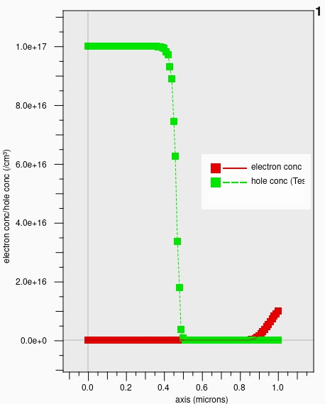
d)From the below electric field plot, the depletion width is determined to be approx. 0.6um with the larger portion towards the ntype region
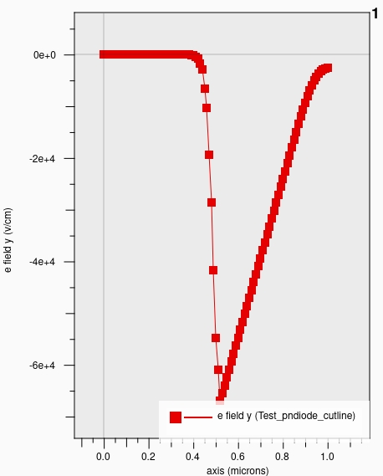

- Analytically;
$$W=\sqrt{\frac{2ϵ{(V}_{bi}-Va)}{q}(\frac{1}{NA}+\frac{1}{ND})}=0.5um$$
Q6. a)
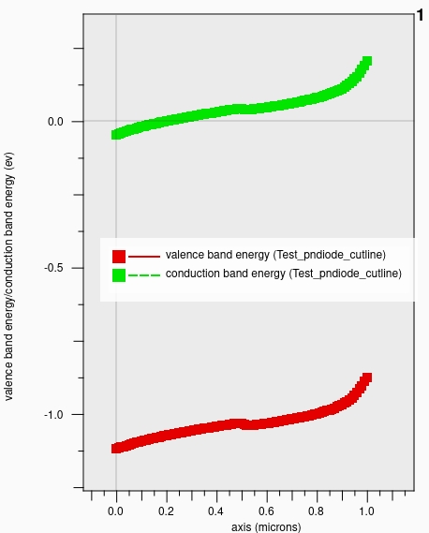

b)
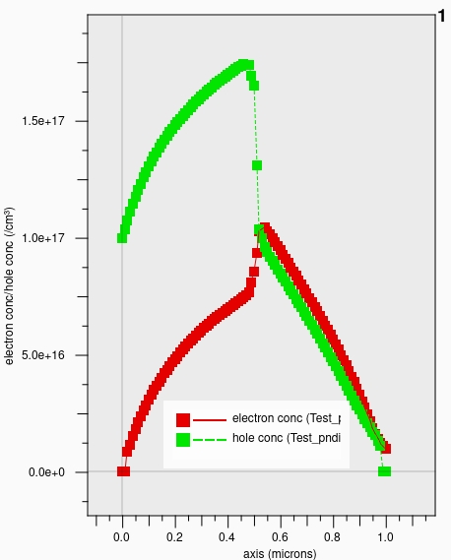
c)

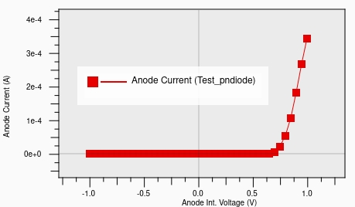

Q7 a)
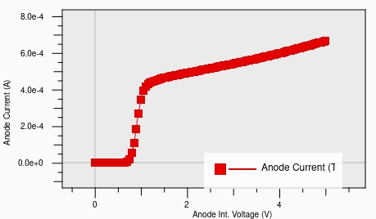
b
a
c

- Cut off region
- Linear region
- Saturation region

